Lab 2: Introduction to Basic Networking Tools and Commands

Objective:
To familiarize essential networking tools and commands used for troubleshooting, diagnosing, and managing network configurations.

Theory:
Networking tools are vital for system administrators and users to diagnose and troubleshoot network issues. These tools allow us to monitor connections, view configurations, detect reachability, and inspect data flow. Below are some of the most commonly used commands:

ipconfig / ifconfig
Purpose: View IP address and network info
- ipconfig – for Windows
- ifconfig – for Linux / macOS
- Shows: IP address, Subnet mask, Default gateway (router address)
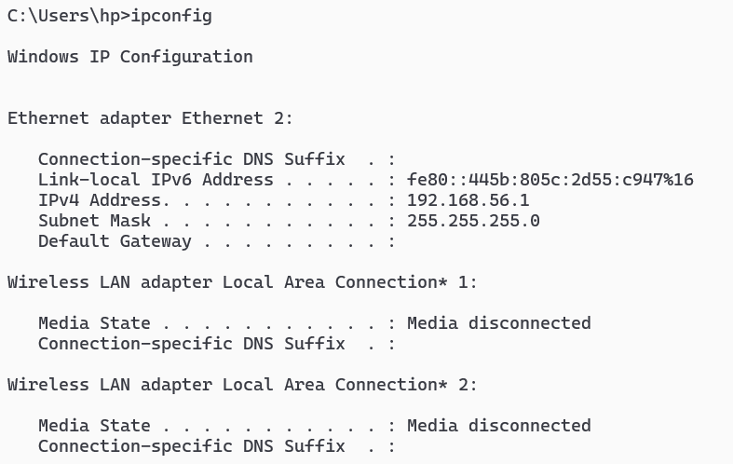
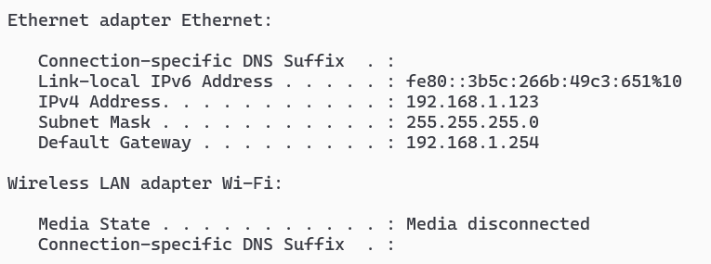

ping
Purpose: Test if another device is reachable
- Example: ping google.com
- Sends packets and checks for replies
- Useful for checking if the internet or a server is working
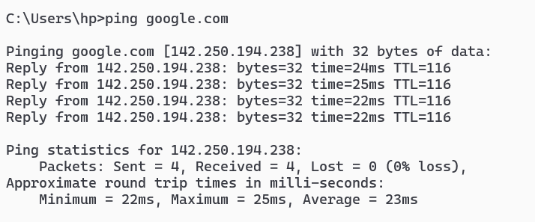

tracert / traceroute
Purpose: See the path data takes through the network
- tracert – Windows, traceroute – Linux/macOS
- Example: tracert google.com
- Shows each hop your data takes; helps identify slow or failed connections

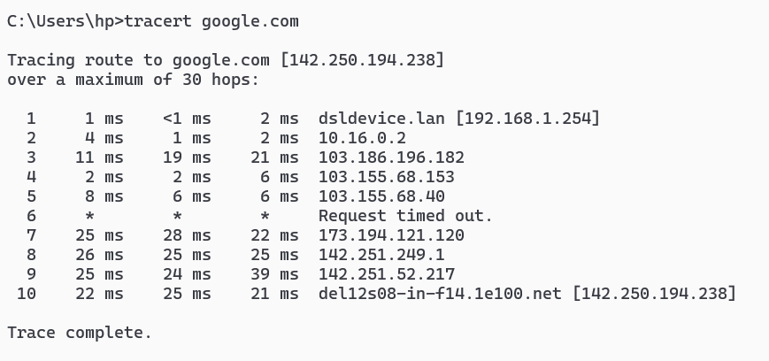

netstat
Purpose: View network connections and ports
- Example: netstat -an
- Displays active connections, used/listening ports
- Helps diagnose server port issues
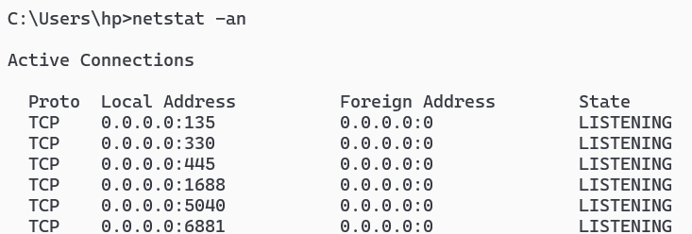
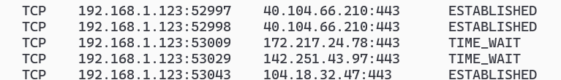

nslookup
Purpose: Check DNS (Domain Name System) resolution
- Example: nslookup google.com
- Converts domain names into IP addresses
- Helpful for diagnosing DNS issues
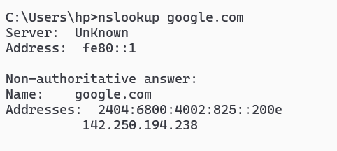

arp
Purpose: Shows IP to MAC address mappings
- Example: arp -a
- Lists local network IP and MAC address bindings
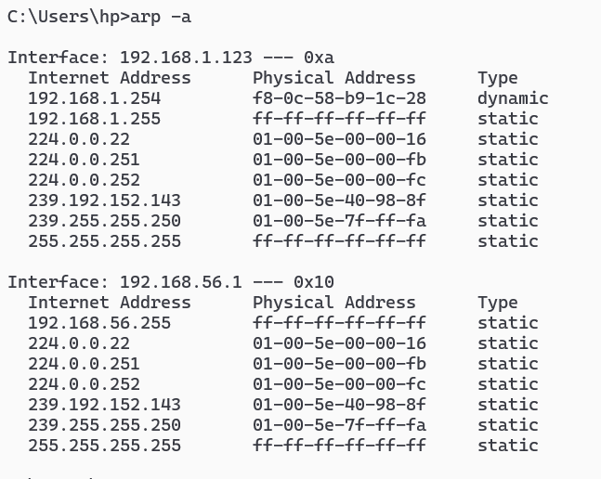

hostname
Purpose: Shows the computer’s name on the network
- Example: hostname
- Useful for identifying the system on the network


telnet
Purpose: Check if a specific port is open on a host
- Example: telnet google.com 80
- Used to test remote server ports (though often disabled by default)

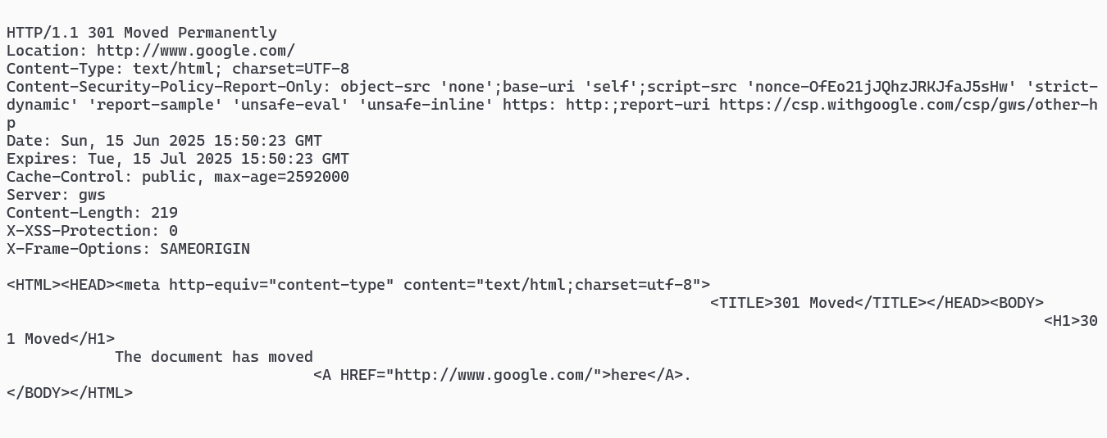

Conclusion:
This lab provided hands-on experience with essential networking commands. These tools help in understanding how networks operate and allow for effective diagnosis and troubleshooting of network-related issues.

